**MAGNUM PEDESTAL FANS:**

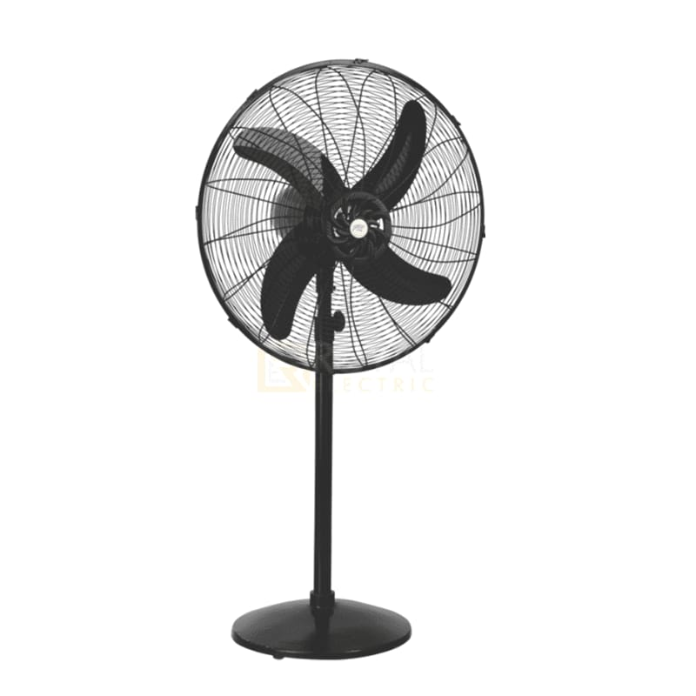

**Price: 12,895.00**

Magnum Pedestal Fans are high-performance cooling solutions designed for heavy-duty use. With their robust and adjustable pedestal design, these fans deliver powerful airflow and can be customized to fit various spaces. Equipped with high-torque motors and specially designed blades, Magnum Pedestal Fans provide exceptional air circulation, making them ideal for industrial, commercial, and large residential areas. Their durable construction and corrosion-resistant coating ensure long-lasting performance, while their sleek design adds a touch of rugged sophistication.

**Key features of magnum pedestal fans include:**

* **Adjustable Height:** Most Magnum pedestal fans allow you to adjust the height to suit different spaces and needs.
* **Oscillation:** They feature oscillating functionality for wider airflow coverage**.**
* **Multiple Speed Settings:** To customize airflow intensity, offering low, medium, and high settings.
* **Durable Design:** Built with sturdy materials for long-lasting performance.
* **Quiet Operation:** Engineered for quieter operation to ensure minimal noise during use.
* **Tilt Adjustment:** Allows you to direct airflow in different directions for better air distribution.
* **Energy Efficiency:** Designed to consume less power while maintaining good airflow.